**Restarting Self Service (SS) all instances**

**You will need the following:  
User “banner” access to Athena/banapps  
You can obtain the passwords from DCHI**

**If you try accessing SS and it mentions that there is a database connection error there are two possible reasons for it. These instructions are for dev8/test8/live8 instances but if you have any further questions you’re going to have to ask Noemi.**

1. **Database connection credentials/url/etc was changed. You’re going to have to log into the server and change the dads.conf file to include the new parameters/paths/passwords then run the perl obfuscate script to scrample the dads.conf file so that nobody can gain access by merely looking at the file.**

**STEPS**

1. **Stop the server first  
   */home/oracle/Oracle/Middleware/Oracle_WT1/opmn/bin/opmnctl stopall***
2. **Edit the dads.conf file located in the following path by using “vi” to edit it  
   */home/oracle/Oracle/Middleware/Oracle_WT1/instances/instance1/config/OHS/ohs1/mod_plsql/dads.conf***
3. **Locate the url/port/password etc and replace it and save your changes**
4. **Obfuscate the data within the dads.conf file by using the following command  
   *perl dadTool.pl -o -f /home/oracle/Oracle/Middleware/Oracle_WT1/instances/instance1/config/OHS/ohs1/mod_plsql/dads.conf***
5. **Start the server back up again  
   */home/oracle/Oracle/Middleware/Oracle_WT1/opmn/bin/opmnctl startall***
6. **Now try visiting the appropriate instance that**
7. **Database connection was terminated by error and you were probably never notified. You’re going to have to wait until Freddy or whomever the DBA will be to get the database back up and running and then SS will re-establish the database connection itself. Please note that if SS is down for X amount of time you’re going to have to explain why that’s the case with DW.**

**Commands/Scripts for reference:**

**I’ve created two scripts that are located in /home/oracle/scripts named the following:**

**restartopmnctl.sh – Restarts self service dev8  
obfuscatedads.sh – encrypts the password you’ve inputted for self service dev8 inside the dads.conf file.**

**Stopping and starting the server**

**Stopping:  
/home/oracle/Oracle/Middleware/Oracle_WT1/opmn/bin/opmnctl stopall**

**Starting:  
/home/oracle/Oracle/Middleware/Oracle_WT1/opmn/bin/opmnctl startall**

**Please edit the following file: /home/oracle/Oracle/Middleware/Oracle_WT1/instances/instance1/config/OHS/ohs1/mod_plsql/dads.conf**

**To obfuscate… Go to the path of dadTool.pl /home/oracle/Oracle/Middleware/Oracle_WT1/bin/ then run the following command:   
perl dadTool.pl -o -f /home/oracle/Oracle/Middleware/Oracle_WT1/instances/instance1/config/OHS/ohs1/mod_plsql/dads.conf**

**Screenshots below outline the interface for fusion middleware.**

**You can reach weblogic administration console via the following links:**[**http://athena.westernu.edu:7001/console**](http://athena.westernu.edu:7001/console) **(DEV8/TEST8)**[**http://banapps.westernu.edu:7001/console**](http://banapps.westernu.edu:7001/console) **(LIVE8)**

|  |  |
| --- | --- |
| **Weblogic Server. You can use this as a reference. Keep in mind that the best way to learn would be to have hands on with the guide and the server and directly applying/making changes to the system to see how it reacts.** |  |

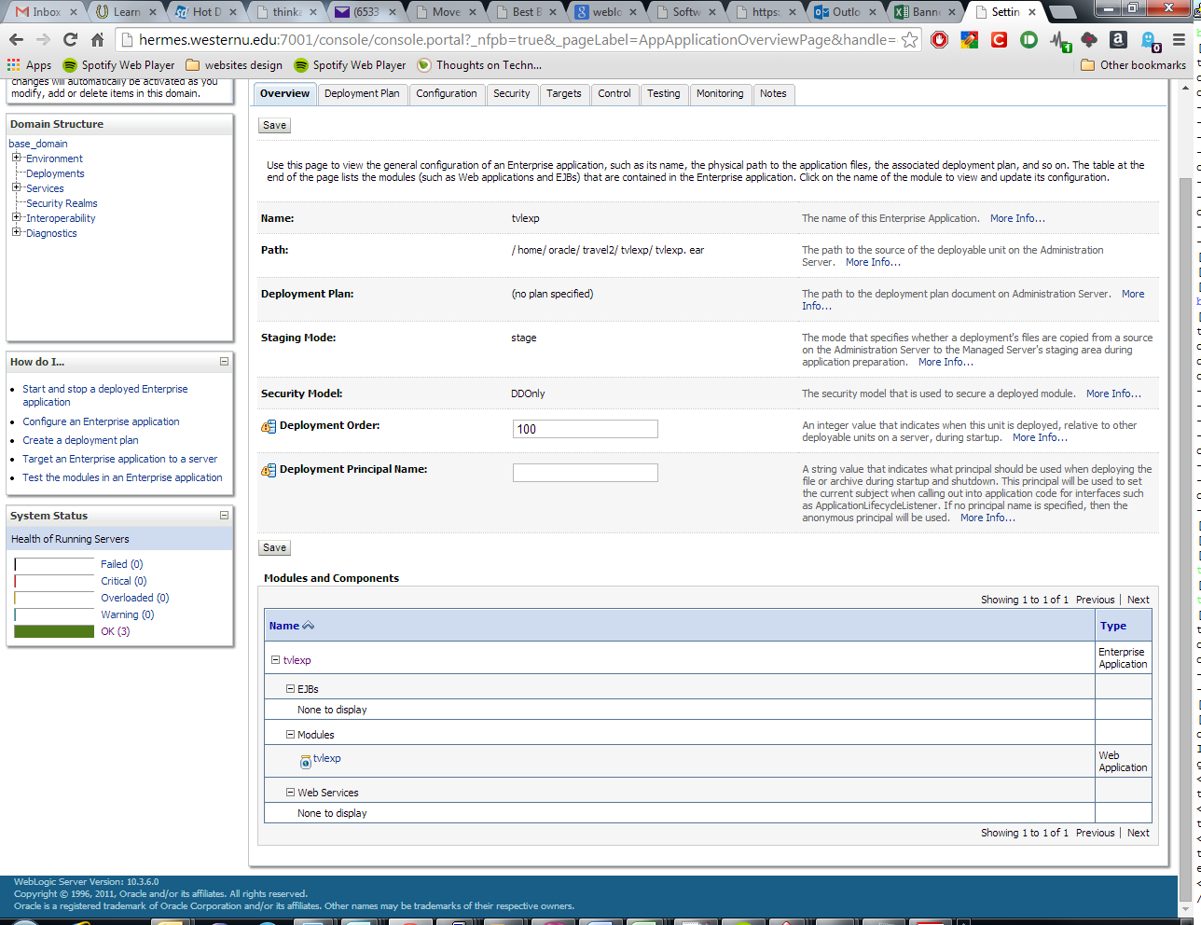

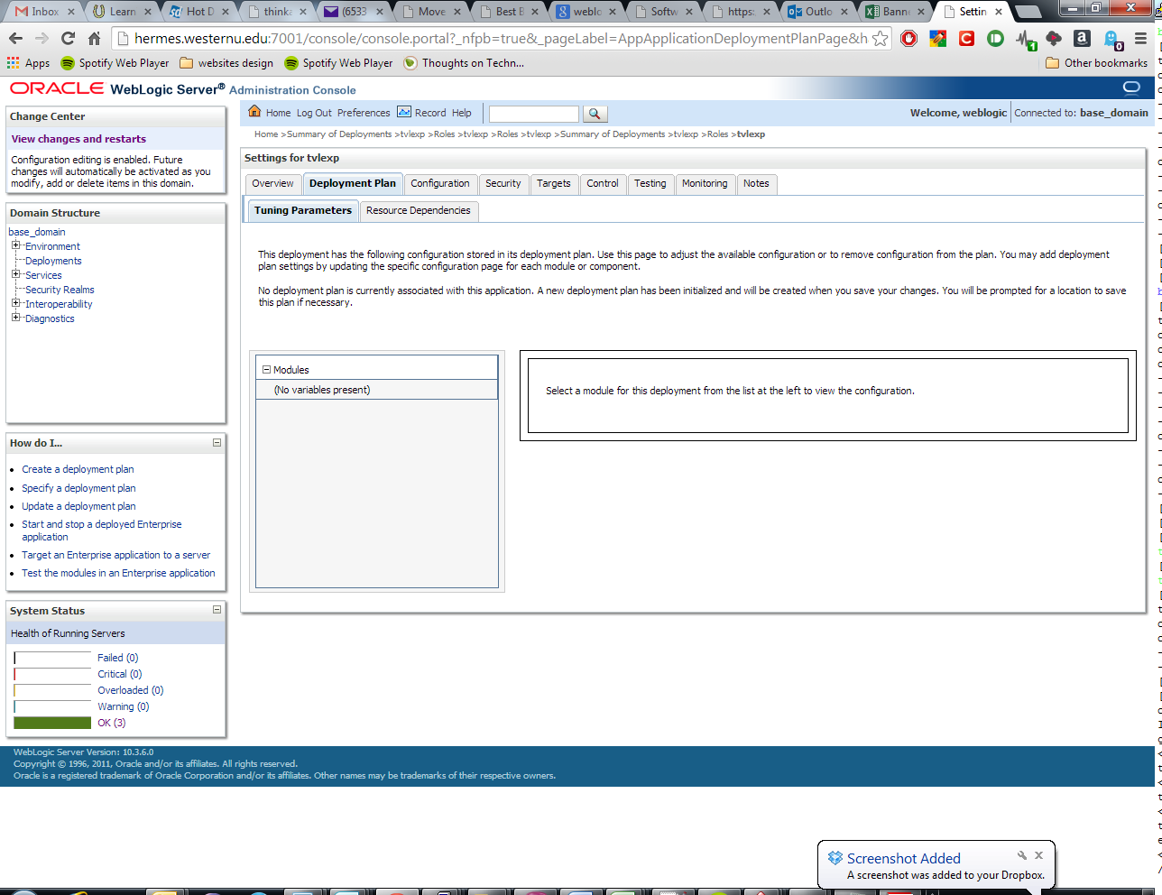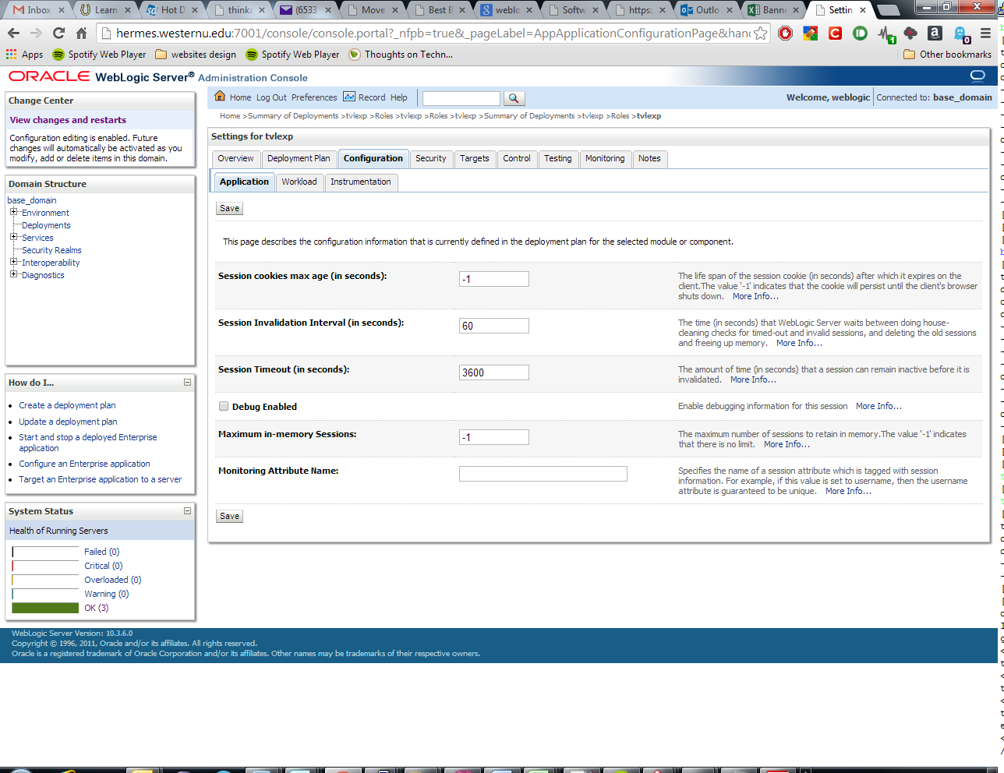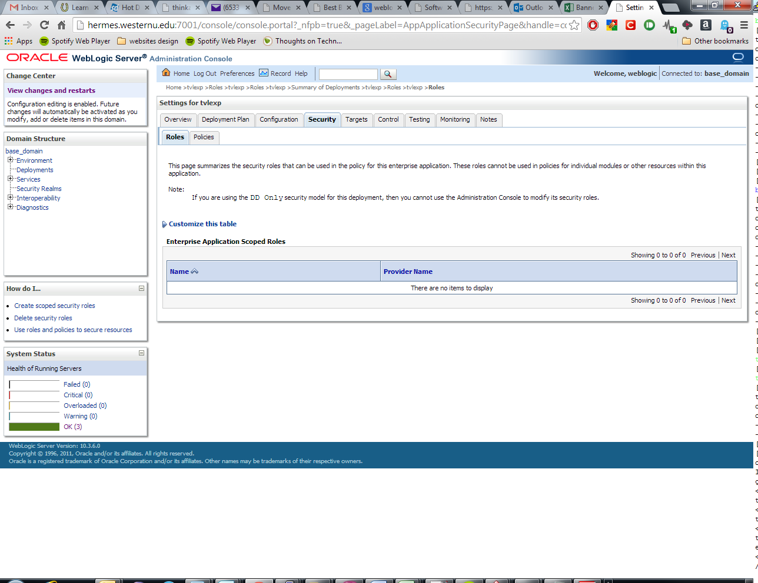

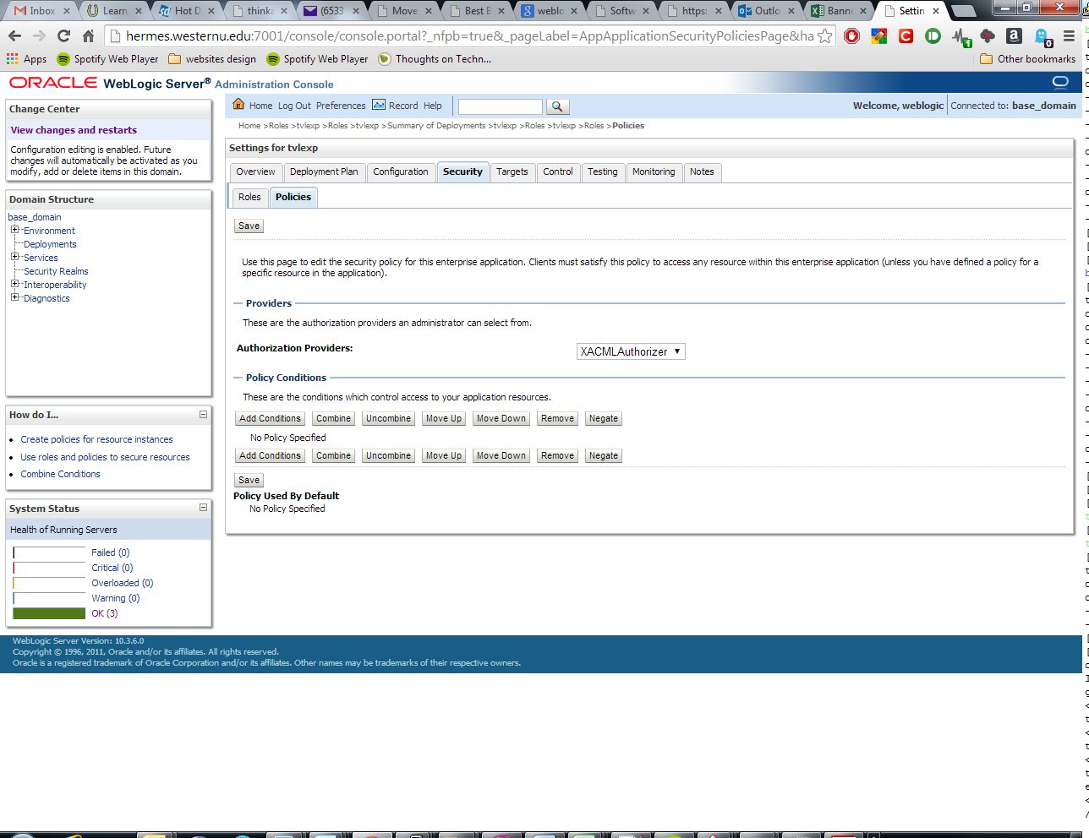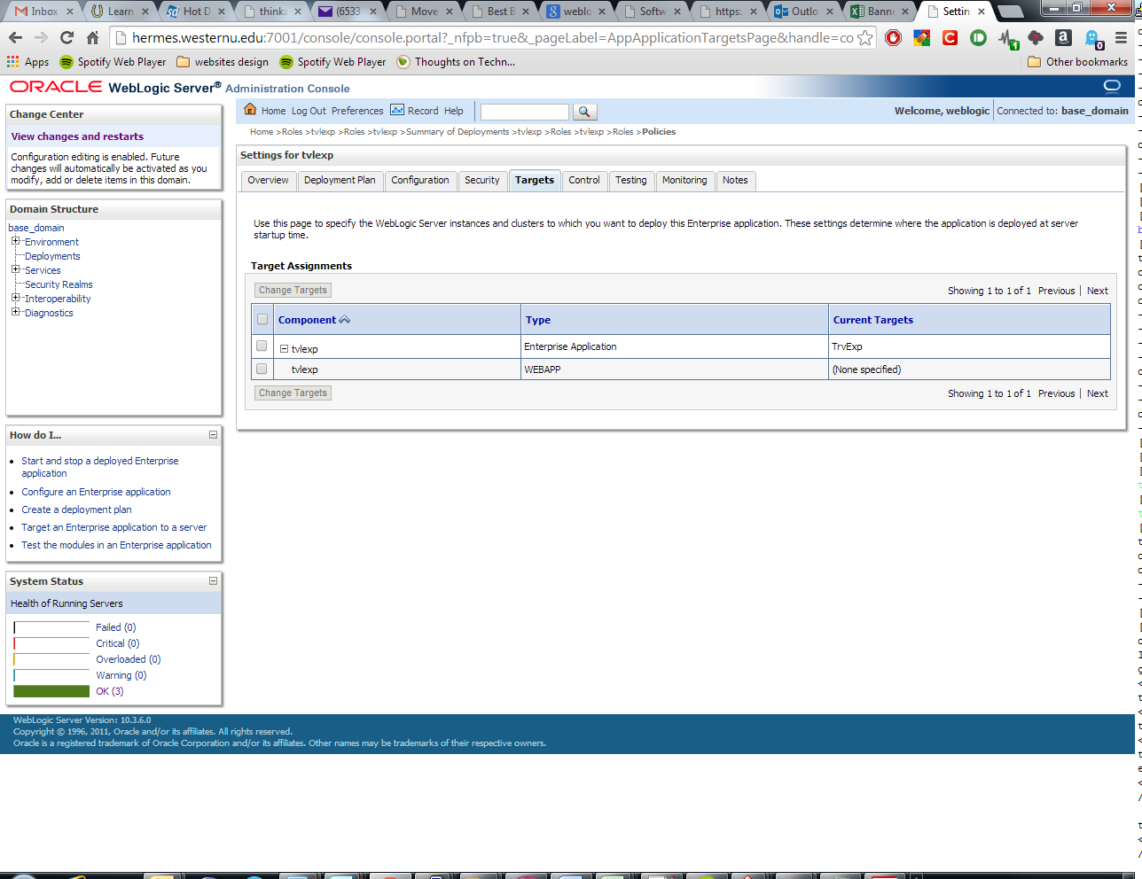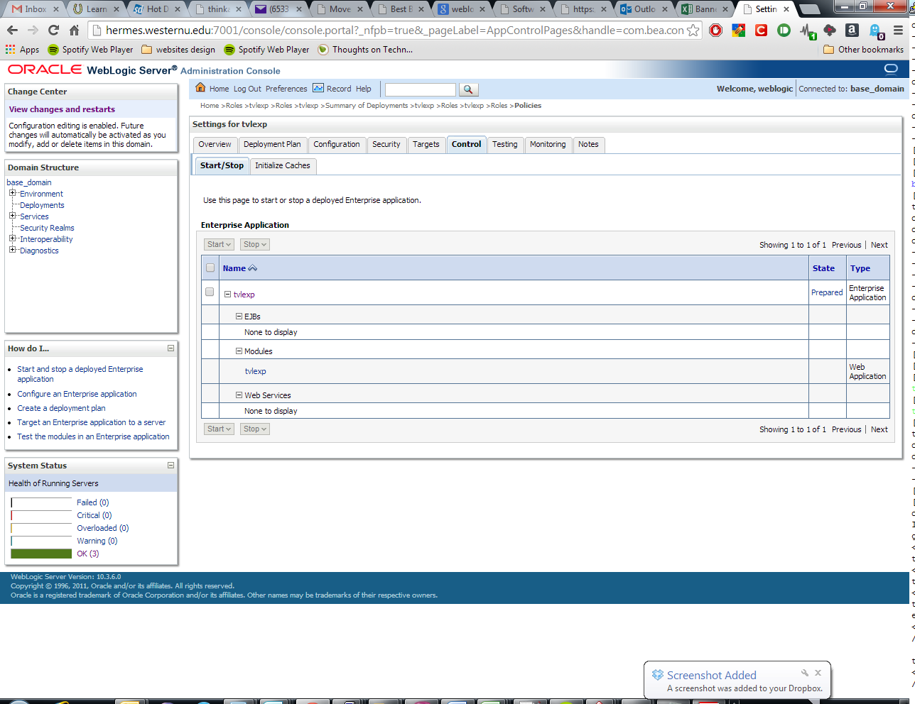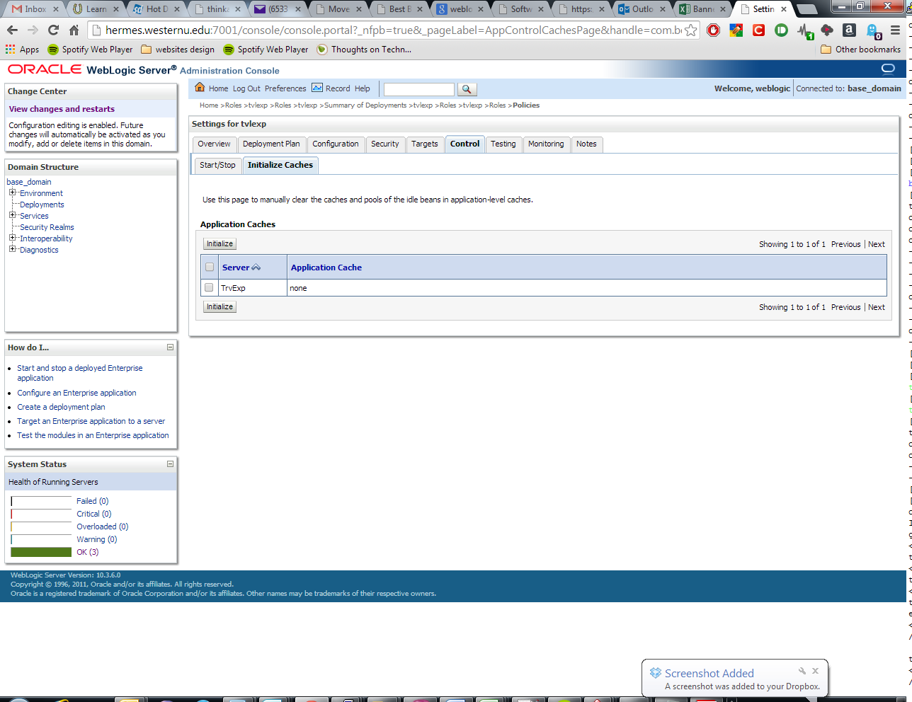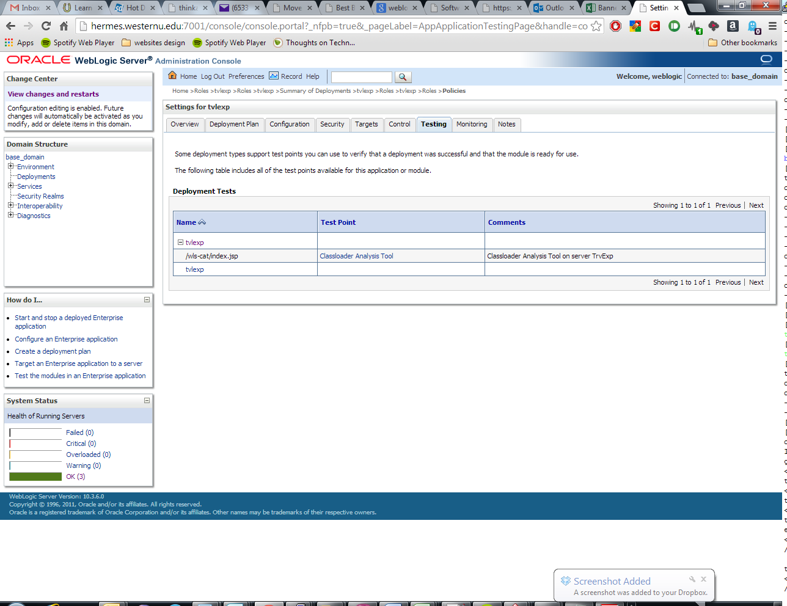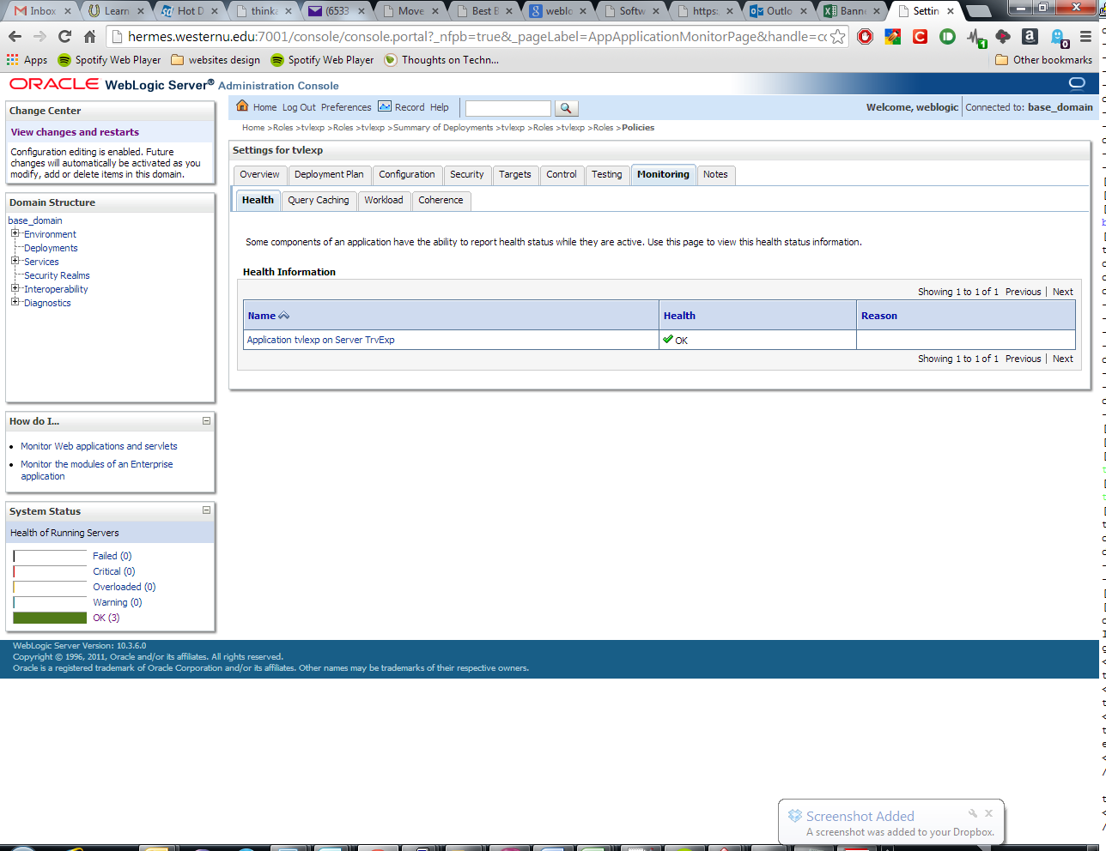

**If there is no established connection, make sure the server is reachable and if not contact the guys downstairs to see if anything has been changed.**